Design and Fabrication of a Pyramidal Horn Antenna



**Prepared by:**

**Tawanda Muzanenhamo**

**MZNTAW004**

Department of Electrical Engineering

University of Cape Town

**Prepared for:**

**Prof B. Downing**

Department of Electrical Engineering

University of Cape Town

**28 April 2020**

**Key Words:** Fekko, Horn Antenna, Microstrip

Contents

Design and Fabrication of a Pyramidal Horn Antenna 1

**Prepared by:** 1

Department of Electrical Engineering 1

**Prepared for:** 1

Department of Electrical Engineering 1

**Key Words:** Fekko, Horn Antenna, Microstrip 1

Table of Figures. 3

Equations 4

Tables 4

Abstract 5

Introduction 5

Aim 6

Design Procedure 6

Antenna Gain 6

Linear Gain 6

Wavelength 6

Effective Area 6

Actual Area 6

Antenna Dimensions 7

Fabrication 9

Horn Antenna from Fekko. 10

Wave Guide 12

Antenna Beam width 12

Fekko Optimisation. 13

Simulation Results 13

Resonant Patch Antenna Array. 17

Microstrip Feed Line. 19

Simulation Results 21

Conclusions 23

References 23

Appendix A. 24

Appendix B. 29

# Table of Figures.

Figure 1: Pyramidal Horn Antenna 5

Figure 2: Horizontal Plane Dimensions 8

Figure 3: Vertical Plane Dimensions 8

Figure 4: Back Dimensions 9

Figure 5: Realised Antenna 1 10

Figure 6: Realised Antenna 2 10

Figure 7: Realised Antenna 3 10

Figure 8:Fekko Horn Antenna Aperture 11

Figure 9: Fekko Horn Antenna Side View 11

Figure 10:Fekko Horn Antenna Back View 12

Figure 11: Flange Dimensions 12

Figure 12: Radiation characteristic of designed antenna for frequency 8.25GHz 14

Figure 13: Sidelobe level of radiation in Antenna 15

Figure 14: Radiation characteristic in polar graph for ϕ = 0° 15

Figure 15:Radiation characteristic in polar graph for ϕ = 90° 16

Figure 16: Resonance Patch Antenna [1] 18

Figure 17: Micro Strip patch [1] 18

Figure 18: Microstrip Feedline [1] 20

Figure 19: Microstrip Diagram [1] 21

Figure 20: Micro Patch Antenna 22

Figure 21: Array Layout 22

Figure 22: Micro Patch Antenna Directivity 23

Figure 23: Currents Arrows 24

Figure 24: Currents 24

Figure 25: Far Field Chart 25

Figure 26: Far field Radiation Characteristic at ϕ = 45° 25

Figure 27: Radiation characteristic in polar graph for ϕ = 45° 26

Figure 28: Near Field Electric Field Infront of Aperture 26

Figure 29: Near Field Electric Field Arrows Infront of Aperture 27

Figure 30: Near Field Electric Field Arrows Inside the Aperture 27

Figure 31: Near field Infront of the Aperture Surface Diagram 28

Figure 32: Near Field Magnetic Field Arrows Infront of Aperture 28

Figure 33: Near Field Poynting Vector Inside the Aperture 29

Figure 34: Near Field Surface Diagram 29

# Equations

Equation 1: Antenna gain 6

Equation 2: Wavelength Equation 6

Equation 3: Effective Area equation 6

Equation 4: Actual Area Equation 7

# Tables

Table 1: Optimisation 13

# Abstract

Horn antennas are widely used in the microwave frequency range. They can also be used as a standard of measuring the gain of other antennas and to feed horns for large antennas like Parabolic antennas. In addition, they can also be used in biomedicine and non-destructive testing. This report discusses the design and fabrication of a pyramidal horn antenna with a gain of 15dB and a centre frequency of 8.25Ghz. The antenna is fabricated from cardboard and covered in kitchen aluminium foil with a thickness of 2mm. Fekko is used to optimise the antenna.

# Introduction

A horn antenna is an antenna that consist of a flaring metal waveguide shaped like a horn to direct radio waves in beam. Depending on the direction of the flaring, microwave horn antennas can be E plane horn or H plane horn EH plane and Pyramidal horn. A pyramidal horn antenna is a horn antenna whose horn is made in the shape of a four-sided pyramid with a rectangular cross section. Pyramidal horn antennas are commonly used with rectangular wave guides and they radiate linearly polarized radio waves. The aperture efficiency of pyramidal horn antenna ranges from 0.4 to 0.8 and increases with the increase in the horn.

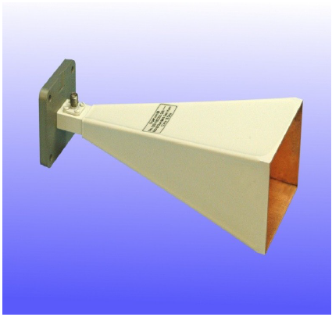

Figure : Pyramidal Horn Antenna

# Aim

The aim of this project is to investigate, design, fabricate and test a pyramidal horn antenna with the following specifications

* 15dB
* 8.0 -8.5GHz frequency band
* 60% aperture efficiency
* Same beam width in the vertical and horizontal plane

# Design Procedure

Aperture efficiency = 0.6

Gain = 15dB

Centre frequency =

## Antenna Gain



Equation : Antenna gain

## Linear Gain

## Wavelength

Equation : Wavelength Equation

## Effective Area



Equation : Effective Area equation

## Actual Area



Equation : Actual Area Equation

## Antenna Dimensions

The pyramidal horn antenna must have the same beam width in the H-plane and E Plane.

The H plane dimension is of the E plane

The length of the horn antenna

The dimensions are shown below.

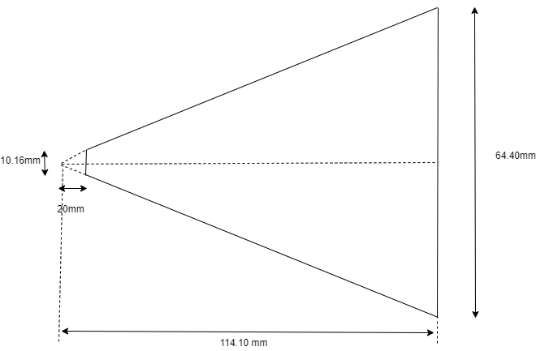

Figure : Horizontal Plane Dimensions

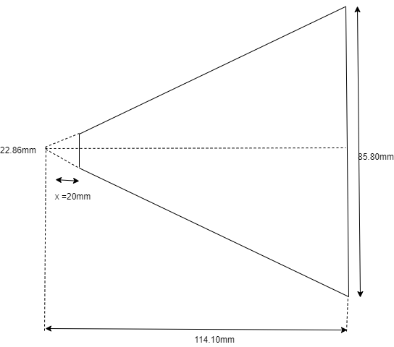

Figure : Vertical Plane Dimensions

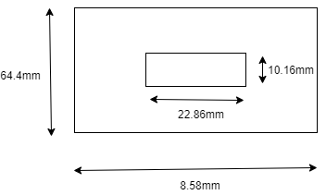

Figure : Back Dimensions

The Calculations for the x in Figure 3: Vertical Plane Dimensions Figure 2: Horizontal Plane Dimensions value and the theoretical beam width are detailed below.

# Fabrication

This section includes the cutting, bending and joining of all the materials together. A cereal cardboard box and aluminium kitchen foil. In order to maximise the electrical performance of the antenna, the bent sides are bent first and then joined. Glue is used stick the aluminium foil to the cardboard boxes and join the cardboard boxes.

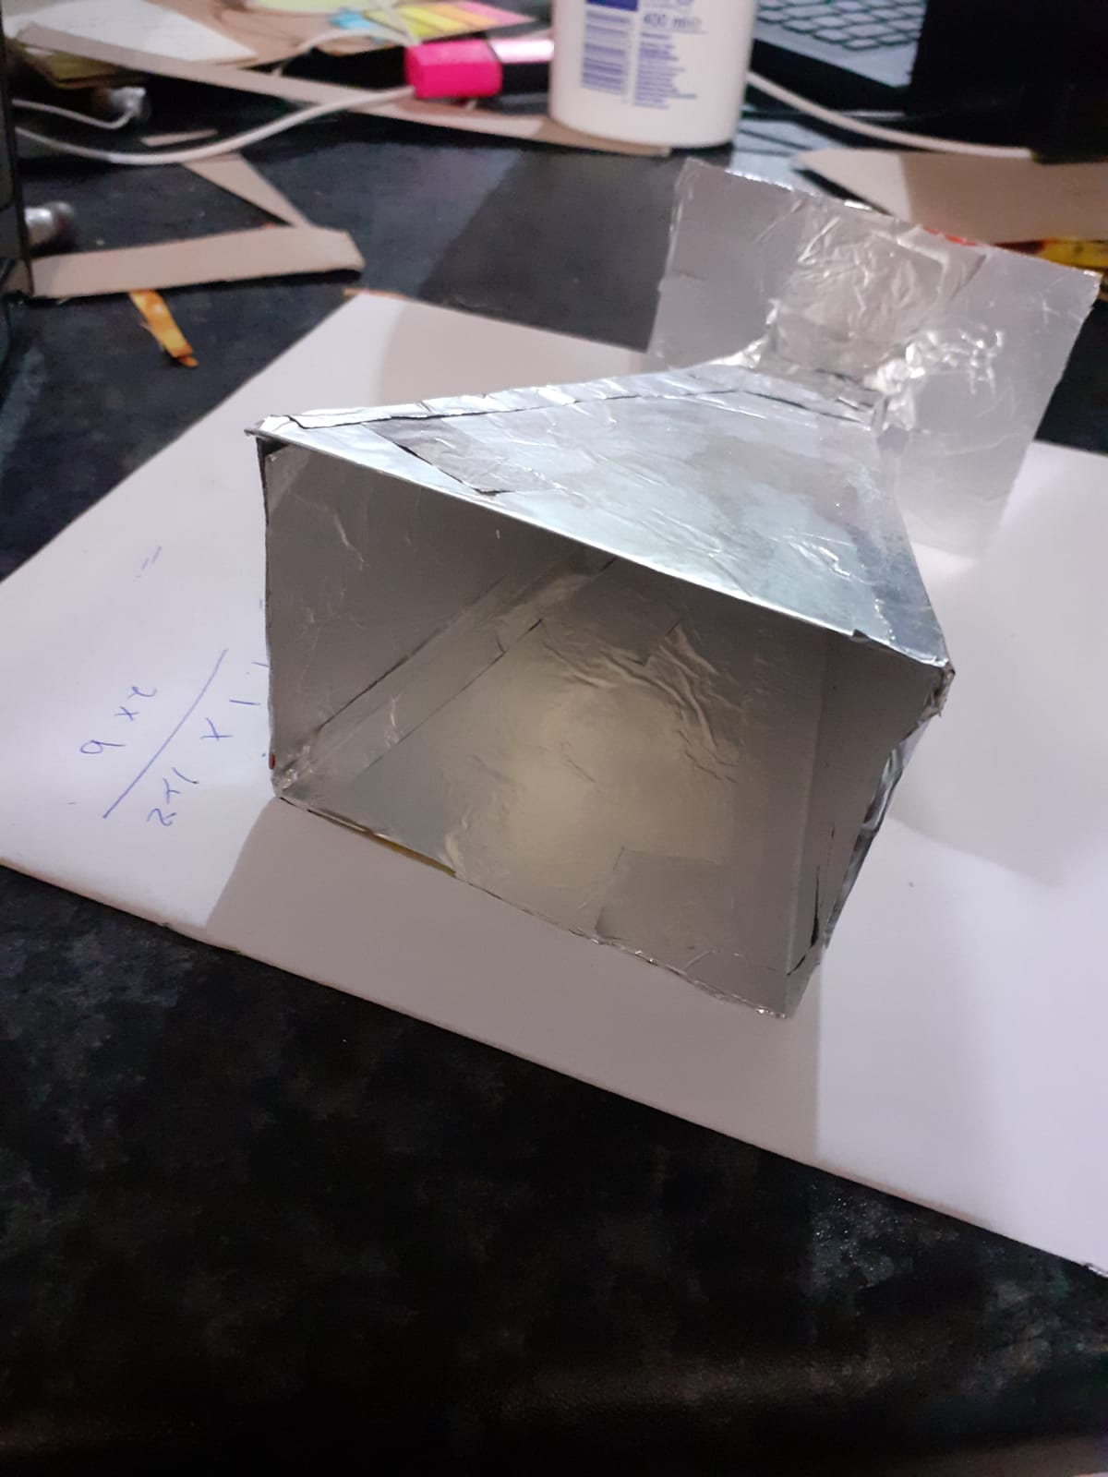

Figure : Realised Antenna 1

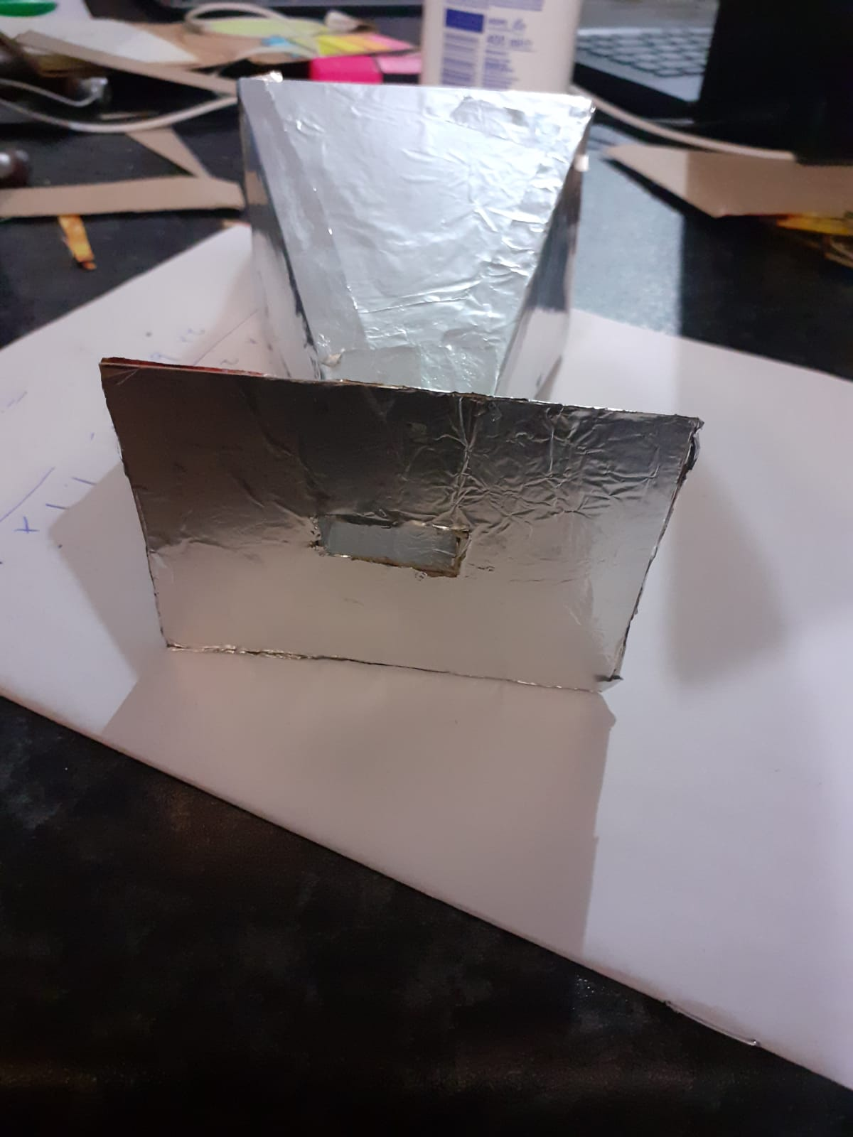

Figure : Realised Antenna 2

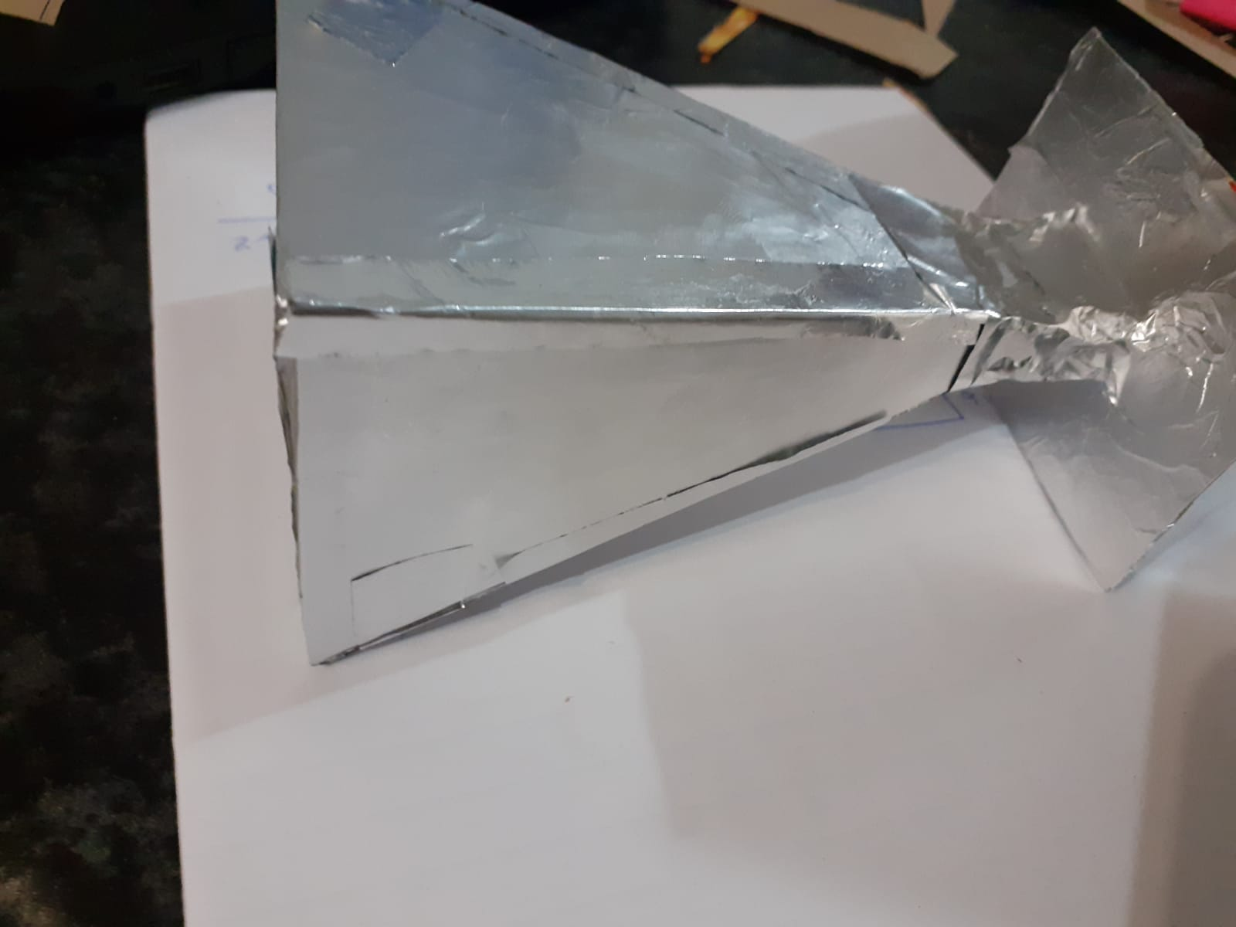

Figure : Realised Antenna 3

# Horn Antenna from Fekko.

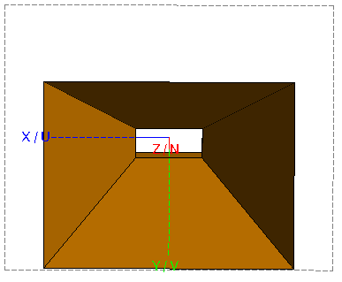

Figure :Fekko Horn Antenna Aperture

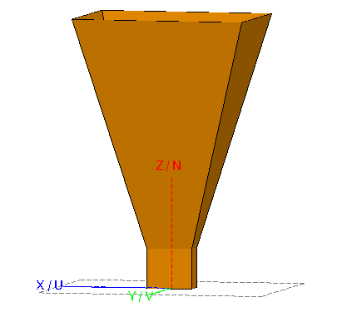

Figure : Fekko Horn Antenna Side View

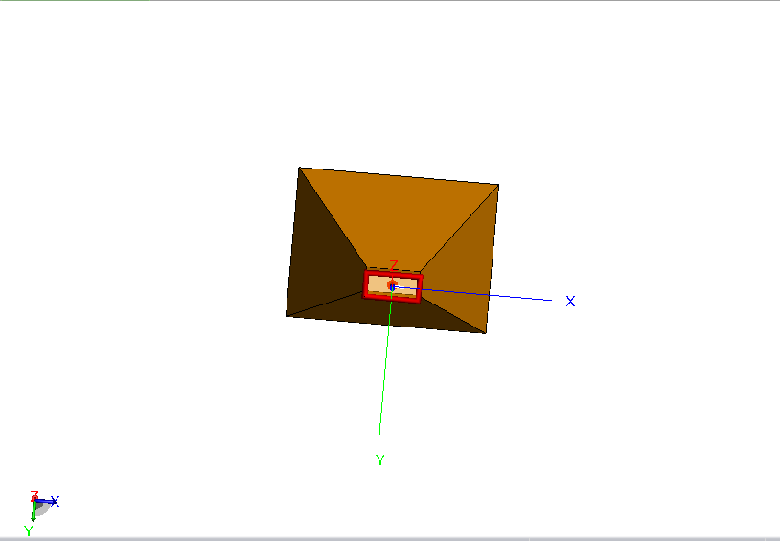

Figure :Fekko Horn Antenna Back View

# Wave Guide

The Pyramidal horn antenna will be fed from an X-band waveguide with internal dimensions of 22.86mm x 10.16mm. In order to make the flange more practical, dimensions of 23mmx10mm were chosen.

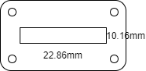

Figure : Flange Dimensions

# Antenna Beam width

Theoretical beam width of the antenna.

# Fekko Optimisation.

|  |  |  |  |  |
| --- | --- | --- | --- | --- |
| Length (cm) | a (cm) | b (cm) | Gain (dB) | Deviation % |
| 11.41 | 8.58 | 6.44 | 15.9477 | -6.38 |
| 11 | 8.40 | 6.35 | 15.765 | -5.1 |
| 10.5 | 8.25 | 6.15 | 15.5486 | -3.66 |
| 10 | 8 | 6 | 15.2372 | -1.58 |
| 9.5 | 7.5 | 5.5 | 14.8645 | 0.90 |
| 9.65 | 7.65 | 5.65 | 15.0855 | -0.57 |
| 9.6 | 7.61 | 5.62 | 15.0035 | -0.02 |

Table : Optimisation

After optimising the antenna dimensions using Fekko, the new dimensions which give the required 15dB gain within the 2% error is

L = 9.6cm

a = 7.61cm

b = 5.62cm

# Simulation Results

The optimised antenna has following radiation characteristics.

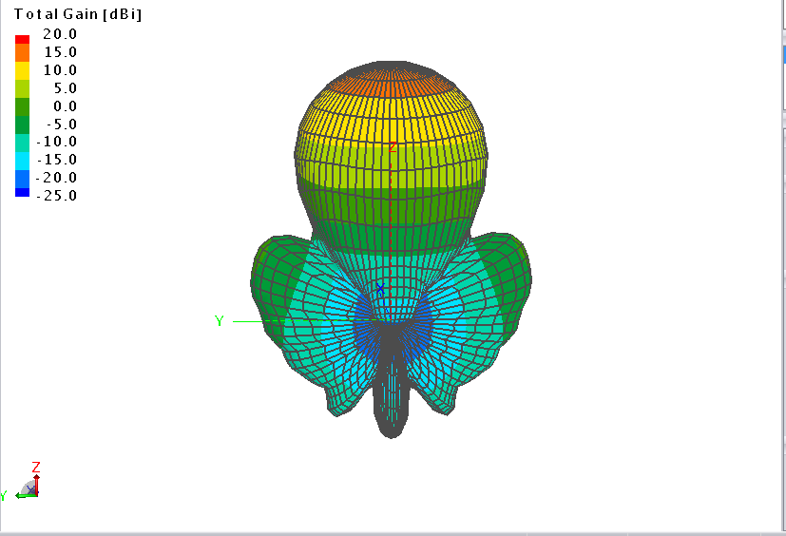

Figure : Radiation characteristic of designed antenna for frequency 8.25GHz

The scale on the top left is in decibel scale. The largest gain area is coloured in orange whereas the lowest gain is coloured in blue. From the diagram, the gain in the main direction is 15dB as shown by the scale the orange region is the main direction.

The most important of an antenna is the ratio of level of radiation for different directions. Radiation in the direction of the main lobe is characterised by the higher value of radiation. The distance between the radiations in the main lobe in comparison with the second local maximum of radiation determines the sidelobe level radiation (SLL) The value of SLL in the simulated antenna is 21.588 dB as shown in Figure 13. A higher value for this value ensures less interference caused by radiation of the same signal spread out in different directions.

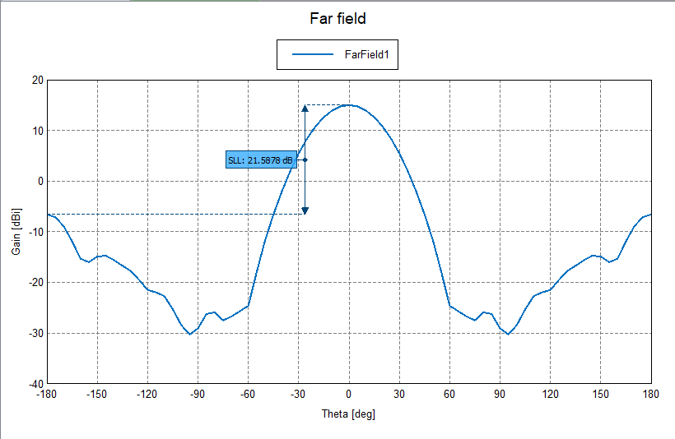

Figure : Sidelobe level of radiation in Antenna

The radiation characteristic of the designed antenna shown in polar coordinates in the cut of plane at an angle is shown in Figure 14. The decrease in power by 3dB (half power beam width) causes a change in the angle of radiation to 32.483.

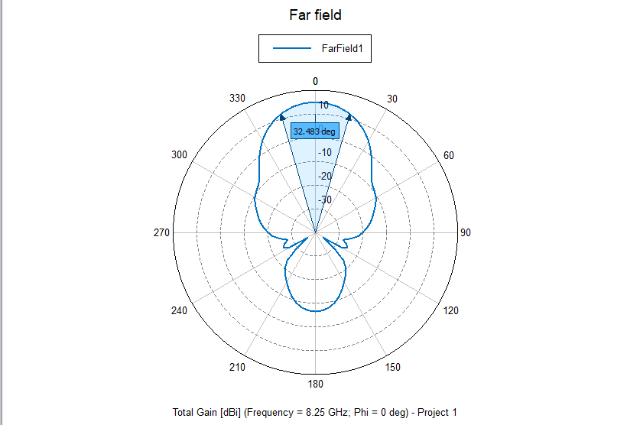

Figure : Radiation characteristic in polar graph for ϕ = 0°

The radiation characteristic of the designed antenna shown in polar coordinates in the cut of plane at an angle of is shown in Figure 15. A decrease in power by 3bD would result in the radiation angle shrinking to 33.4971.

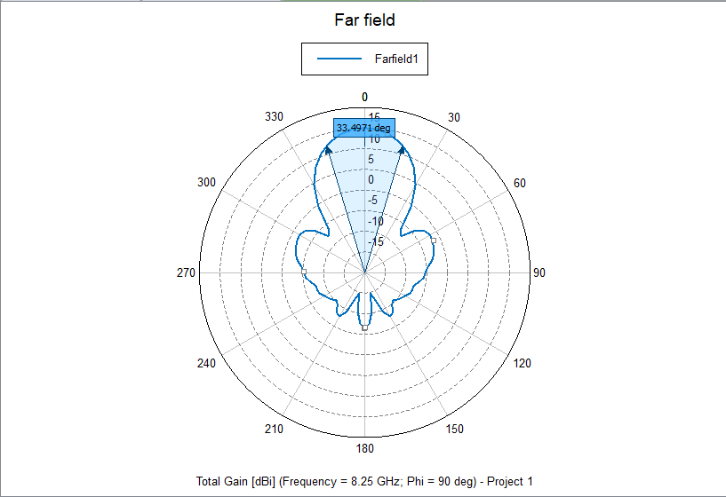

Figure :Radiation characteristic in polar graph for ϕ = 90°

Figure 16 shows the relationship between Gain and Frequency. Theory dictates that, as the frequency used by a horn antenna increases, so does the gain and the directivity. This can be attributed to the size of the aperture remains constant in terms of physical dimensions, hence increasing frequency increases the number of wavelengths thereby increasing gain.

Figure : Frequency Vs Gain

Other diagrams obtained from the simulation can be found in Appendix A.

# Resonant Patch Antenna Array.

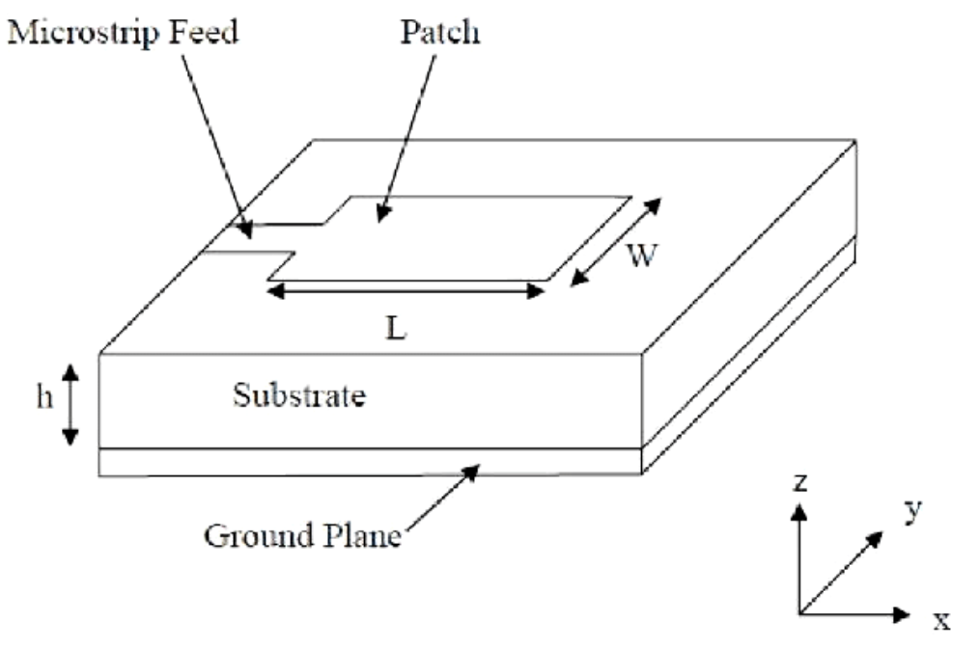

Figure : Resonance Patch Antenna [1]

Aluminium is chosen as the dielectric material; it has a dielectric constant of εr = 9.8.

Determining the effective constant of the microstrip.

Determining effective length

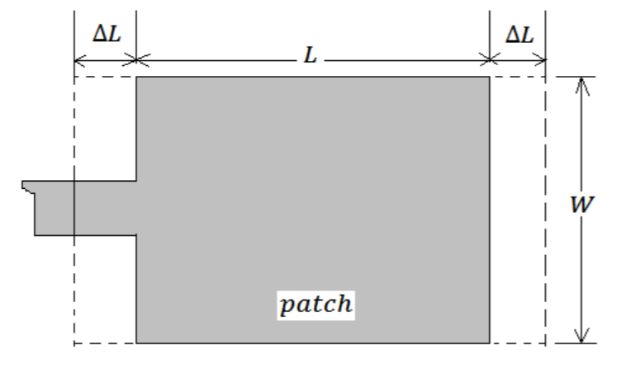

Figure : Micro Strip patch [1]

**0.786.**

The actual length is

Length on the ground is

**Width on the ground is**

**2W**

# Microstrip Feed Line.

The input impedance of the microstrip feedline is assumed to be 50Ω.

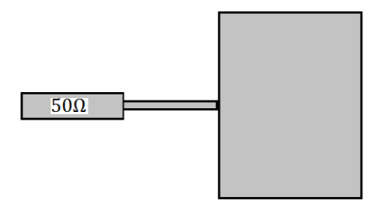

Figure : Microstrip Feedline [1]

Patch Impedance

The width of the transition line can be given by

The width of the transition line is given by.

Ratio is

Since the ratio is greater than 1, then the formula below is used.

The using change of subject, the value of is obtained to be 1.35mm

The length of the Strip is given by

The Length of the Transmission line is given by:

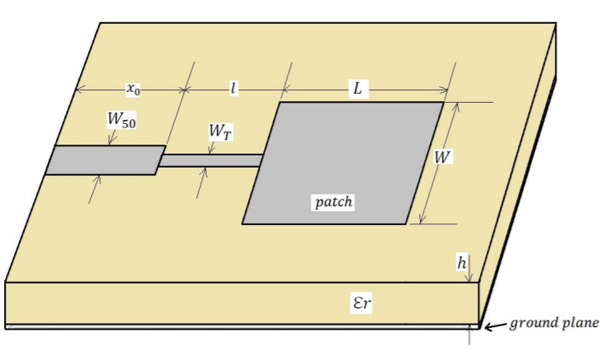

Figure : Microstrip Diagram [1]

# Simulation Results

The following Diagrams were simulated using MATLAB.

Figure 21 illustrates the microstrip patch antenna simulated in MATLAB

Figure : Micro Patch Antenna

Figure 22 illustrates how the arrays will be laid out.

Figure : Array Layout

Figure 23 illustrates the directivity of the Micro Patch Antenna and the 3D model on the bottom left corner.

Figure : Micro Patch Antenna Directivity

# Conclusions

The purpose of this report was to design and fabricate a pyramidal horn antenna operating at 8.25GHz. The designed antenna was to have a gain of 15dB. From the theoretical calculations, the aperture of the antenna was found to have a length of 11.41 cm, a value of 8.58 cm and b value of 6.44cm. After optimisation using Fekko, the dimensions to give the desired gain with an error range of ±0.02 were found to be length of 9.6cm , a of 7.61cm and b of 5.62 cm as illustrated in Table 1.

The difference in the values can be attributed to the assumptions made during the theoretical calculations, e.g. assuming the aperture has 60% efficiency.

# References

|  |  |
| --- | --- |
| [1] | A. F. Alsager, “Design and Analysis of,” University College of Borås , 2011. |

# Appendix A.

The following images were obtained during the Fekko simulations. The files can be found on the following GitHub repo <https://github.com/tmuzanenhamo/Pyramidal-Horn-Antenna>.

Figure : Currents Arrows

Figure : Currents

Figure : Far Field Chart

Figure : Far field Radiation Characteristic at ϕ = 45°

Figure : Radiation characteristic in polar graph for ϕ = 45°

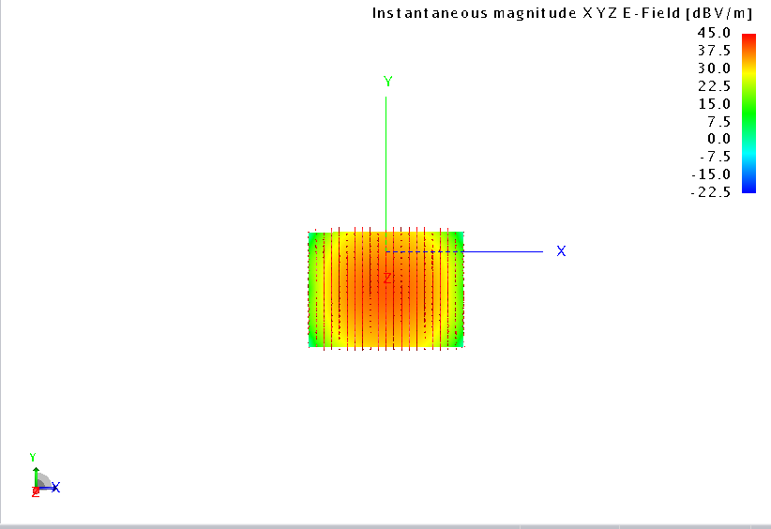

Figure : Near Field Electric Field Infront of Aperture

Figure : Near Field Electric Field Arrows Infront of Aperture

Figure : Near Field Electric Field Arrows Inside the Aperture

Figure : Near field Infront of the Aperture Surface Diagram

Figure : Near Field Magnetic Field Arrows Infront of Aperture

Figure : Near Field Poynting Vector Inside the Aperture

Figure : Near Field Surface Diagram

# Appendix B.

The following Python Script can be used to Calculate the dimensions for the microstrip patch antenna.

